**Bazaar.com – Online Shopping Mall**

**Software Requirements Specification**

Version 1.0



**Group Id: F230226693**

**Supervisor Name: Ayyaz Altaf Mirza**

**Revision History**

|  |  |  |  |
| --- | --- | --- | --- |
| **Date (dd/mm/yyyy)** | **Version** | **Description** | **Author** |
| 08/12/2023 | 1.0 | The Software Requirement Specification(SRS) document serves as the initial phase in the software development life cycle. Within the SRS document, we delineate the project's scope and construct use case diagrams to illustrate the system's actors and essential scenarios. Additionally, the document includes the creation of a project plan and deliberation  on development methodologies. | BC170403299 |
|  |  |  |  |
|  |  |  |  |
|  |  |  |  |

**Table of Contents**

1. Scope (of the project)
2. Functional Requirements Non Functional requirements
3. Use Case Diagram
4. Usage Scenarios
5. Adopted Methodology
6. Work Plan (Use MS Project to create Schedule/Work Plan)

SRS Document

**Scope of Project:**

This project is about providing home delivery service and aims to provide a diverse range of products across multiple categories, catering to the varied needs and preferences of online shoppers. It’s a web application simplifies the process of purchasing groceries and home-related items from the comfort of customers' homes. This Bazaar.com provides exclusive discounts for users registering online and a user will be able to purchase / make order against available items after getting registered or as a visitor on the website and passing through the payment method (cash on delivery). The website will provide interactive interfaces and rich search facility for finding different types of products through different filters. Besides, the registered users will be able to submit their complaints / feedback regarding the website services. As we know that today is the age of e-commerce, and we know many e-commerce web and applications are part of our daily life. This Bazaar.com will be another addition for local e-commerce and make it possible to order and deliver products in multiple categories.

**Functional and non Functional Requirements:**

Functional Requirements:

1. **User Registration/Sign Up, Sign in:**

* **Four** types of the users Online Bazaar web application Visitor (Unregistered User) , Registered user (Buyer/Customer) , Registered user (Seller) , Registered user (Administrator).

3.1.3 Provide Search facility.

3.1.3 Provide Search facility.

1. **Provide rights/privileges facility different User**

* **Visitor** will be able to visit the website to search products.
* The system shall enable user registered as a **Buyer/Customer** will be able to place order on the website with special **discount of 5%**.
* The system shall enable **Seller** will be able to open a store on the website and can sell goods.
* The system shall enable admin will have all the **rights/privileges** information management regarding the **items**, **stock** management, as well as **user** management.

**3) Provide shopping cart facility.**

* The system shall provide shopping cart during online purchase.
* The system shall allow user to add/remove products in the shopping cart.

.

1. **Email confirmation.**

* The system shall send an order confirmation to the user through email.

**Non-Functional Requirements**

All non-function requirements are given below;

|  |  |
| --- | --- |
| **Non-functional**  **Requirement** | **Description** |
| **Availability:** | The website should be available 24/7, with minimal scheduled maintenance periods and Application will be able to work on any sort of operating system which has a browser and internet connection. |
| **Scalability:** | The website should be scalable to accommodate an increasing number of products, users and interface should be user friendly system. |
| **Response Time:** | Define acceptable response times for various actions on the website, such as page loading, search queries, and application will be able to work with a sufficient speed of internet connection. |
| **Security:** | Define requirements for authentication, authorization, and encryption, granting access based on users' roles. |
| **Capacity Planning:** | The Application System should be capable of supporting multiple users at a time. |
| **Compatibility:** | The website should be compatible with various browsers (e.g., Chrome, Firefox, Safari) and devices (e.g., desktops, tablets, smartphones). |

**Use Case Diagram(s):**

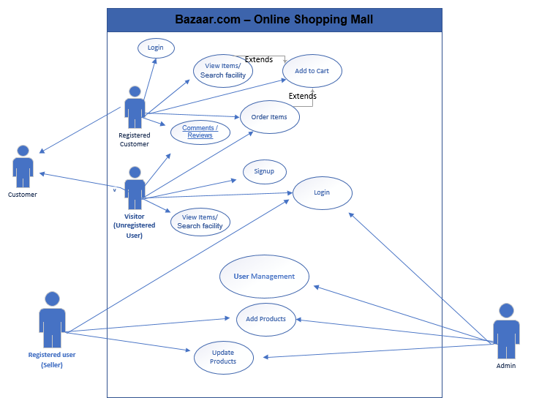

**Usage Scenarios:**

**Sign-Up**

|  |  |
| --- | --- |
| Use Case Title | Sign-Up |
| Use Case Id | UC-06 |
| Actors | User |
| Description | The use case begins when the actor indicates the intent to register to the system. It ends when the actor is a register or cancels registration. |
| Pre-condition | The login exists. |
| Actions | * Open the registration form * Fill the form * Provide complete information * System Show the message in case of success |
| Post-condition | Upon successful account creation, the users will be able to log in to the system using their email and password. |
| Exceptions | If the provided email is already existing in the system, the application will display an alert for change. |
| Author | BC170403299 |

**User Login**

|  |  |
| --- | --- |
| Use Case Title | Login |
| Use Case Id | UC-01 |
| Actors | Administrator/User |
| Description | The use case begins when the actor indicates the intent to login to the system. It ends when the actor is log in or cancels login. |
| Pre-condition | User account must be existing. |
| Actions | * To login server require a valid password * User provides cell number and password * User logins successfully. |
| Post-condition | The actor logs in successfully. |
| Exceptions | user might face login challenges due to account deactivation, password expiration, or other issues. The system should provide clear messages and guidance for resolution, ensuring a secure and user-friendly experience. |
| Author | BC170403299 |

**View Items**

|  |  |
| --- | --- |
| Use Case Title | View Items |
| Use Case Id | UC-02 |
| Actors | User |
| Description | The use case begins when the actor indicates to view the products. It ends when the actor is close to the application |
| Pre-condition | User account must be existing. |
| Actions | * Users can click on a product to view detailed information, including images, descriptions, prices, and customer reviews. * Users have the option to compare multiple products side by side, helping them make informed decisions based on features, specifications, and pricing. |
| Post-condition | The actor view product successfully. |
| Exceptions | When users attempt to view a product that is no longer available or has been removed, the system should display a message indicating that the product is not found and suggest alternative options or similar products. |
| Author | BC170403299 |

**Order Items**

|  |  |
| --- | --- |
| Use Case Title | Order Items |
| Use Case Id | UC-04 |
| Actors | User |
| Description | The use case begins when the actor indicates the intent to confirm the purchase of his selected items. |
| Pre-condition | The user has items in their shopping cart. |
| Actions | * The system sends an email confirmation to the register user. * The user provides or verifies their shipping address. |
| Post-condition | The Cart record is added or updated. |
| Exceptions | * The system prompts the user to correct the address, ensuring accurate delivery, and proceeds with the order once the address is validated. * The system notifies the user of the price change and requests confirmation before proceeding with the updated order total. |
| Author | BC170403299 |

**Adopted Methodology**

“Methodology is a frame work that is used to structure, plan and control the process of developing an information system”.

I have chosen the VU Process Model, which integrates the advantages of both the Waterfall model and the Spiral model. The VU Process Model aims to leverage the strengths of these two methodologies. It also maximizes the quality of system and minimizes any risks and errors.

**VU Process Model**

In the VU Process Model, each project stage undergoes iterative enhancements until it receives approval. If any deficiencies are identified during a stage, they are iteratively recognized and addressed. The model adheres to the principle from the Spiral Model. Once a stage is approved, the subsequent stage commences, drawing inspiration from the sequential progression of the Waterfall Model.

**Reasons for choosing the Methodology**

I select VU Process Model reason is that our project is divided already in different phases.

In which we gathered and analyzed requirements phase that also called SRS Document, Design Document,

Test Phase 1,

Final project report phase and Final report / Presentation. We will complete each phase in sequence and submit it to our Supervisor.

All the activities are performed in a sequence in VU Process Model.

If any improvements require in each phase then he will recommend us about the improvements in each phase before start the next phase.

If Supervisor suggests improvement then we will make improvement in that phase. VU Process Model will be chose due to the spiral nature.

of this model. When the phase is well-improved and well worked-out, and also accepted by our Supervisor then we will proceed to next phase. This will be done due to the waterfall nature of the VU Process model.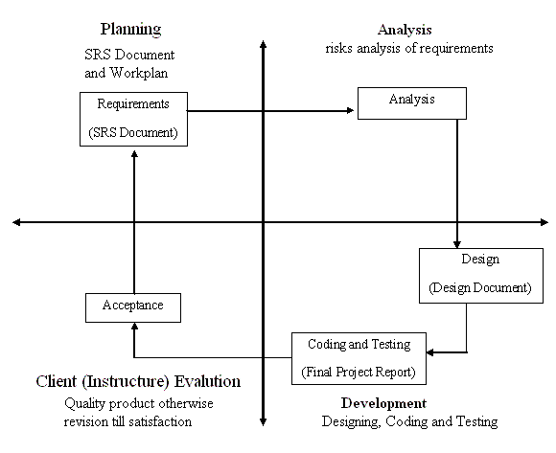

**Work Plan (Use MS Project to create Schedule/Work Plan)**

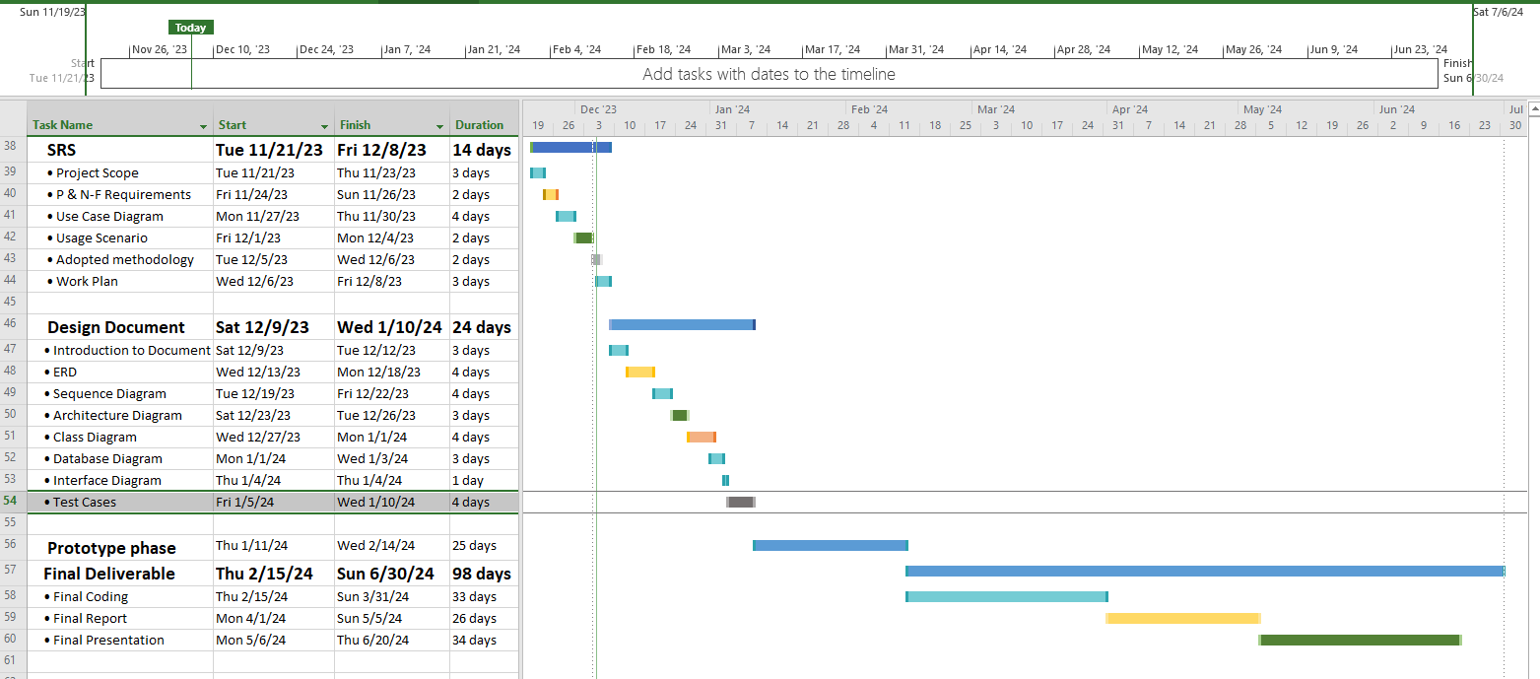

“The End”